# ABC’s Inventory Management System

## Test Script

|  |  |  |  |  |  |
| --- | --- | --- | --- | --- | --- |
| **Test Name** | | Search The Known Transfer And View Its Details (Test Case GRP001) | | | |
| **Use Case Tested** | | Generate Report | | | |
| **Test Description** | | This test tests if the system can search the existing report by known transfer ID and view its details. | | | |
| **Pre-Conditions** | | Meta data must exist, product details like product item code, sending location ID and product quantity; transfer details like transfer date, transfer ID, description. | | | |
| **Post-Conditions** | | A list of products and product details for searching report will be displayed | | | |
| **Notes** | | This test assumes that the user knows the transferID. | | | |
| **Result (Pass/Fail/Warning/ Incomplete)** | | Pass | | | |
|  | **Test Step** | | **Expected Test Results** | **P** | **F** |
| 1. | Select Generate Report Button from home page | | Display the Generate Report page |  |  |
| 2. | Input known transfer ID in search field and click on the Search Button | | System display correct searched transfer |  |  |
| 3. | Click on the “View Product in this Transfer” button to check the products detail of this transfer | | System displays a list of products and its quantity | P |  |

## Data Set 1

|  |  |
| --- | --- |
| **Test Data Table** | |
| **transferID** | 3 |
| **From Date** | N/a |
| **To Date** | N/a |

# Result Screenshots

The screenshots of the result on each test step for each data set are given below:

**Step 1**

Open the Generate Report Page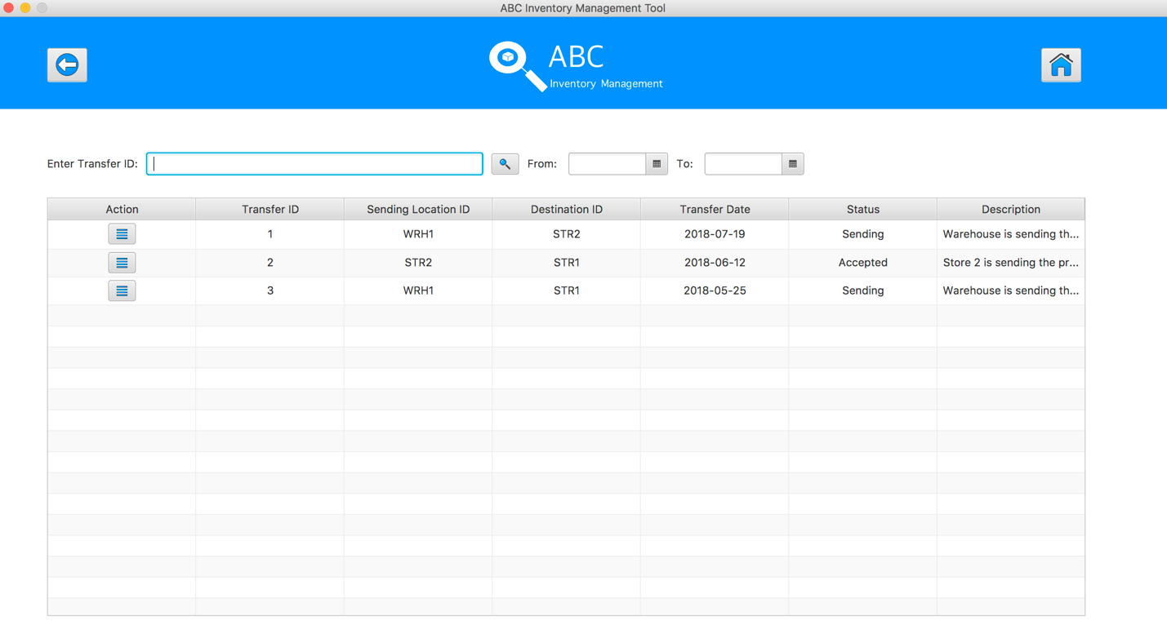

**Step 2**

Input transfer ID in search field and click on the Search Button

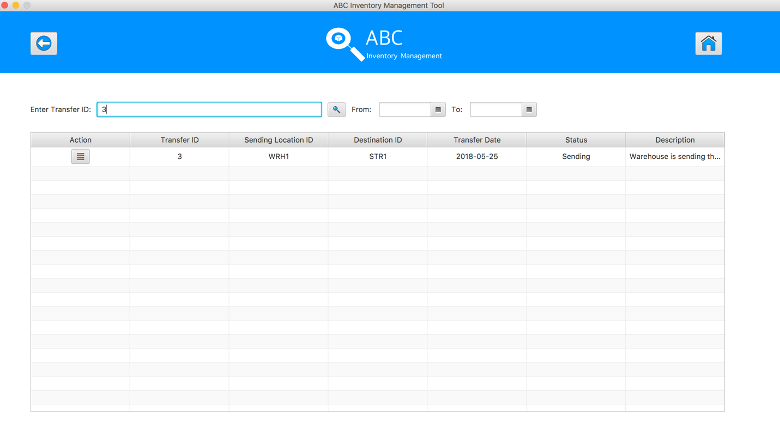

**Step 3**

Click on the “View Product in this Transfer” button, system display a list of product in selected transfer 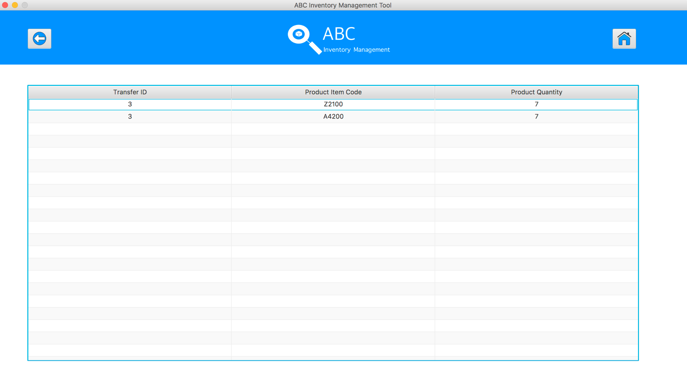

## Data Set 2

|  |  |
| --- | --- |
| **Test Data Table** | |
| **transferID** | 2 |
| **From Date** | N/a |
| **To Date** | N/a |

# Result Screenshots

The screenshots of the result on each test step for each data set are given below:

**Step 1**

Open the Generate Report Page

**Step 2**

Input transfer ID in search field and click on the Search Button

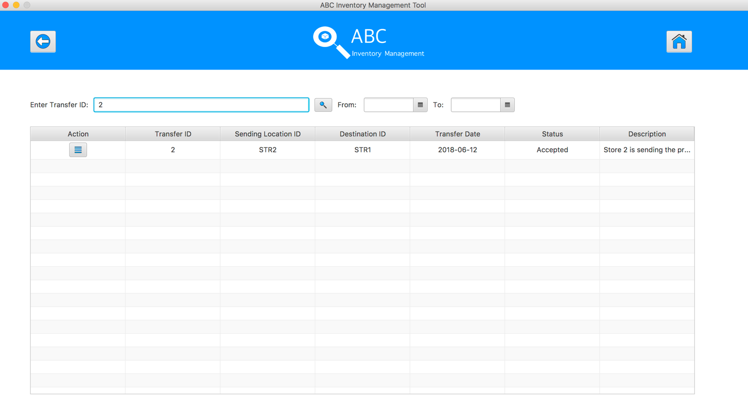

**Step 3**

Click on the “View Product in this Transfer” button, system display a list of product in selected transfer 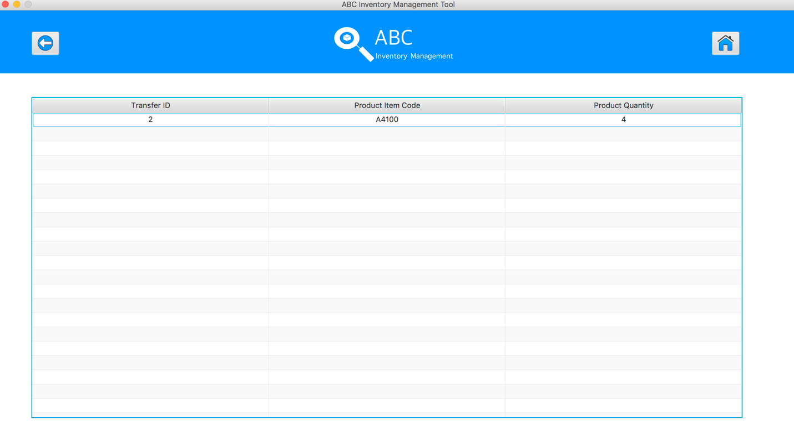

## Data Set 3

|  |  |
| --- | --- |
| **Test Data Table** | |
| **transferID** | 1 |
| **From Date** | N/a |
| **To Date** | N/a |

# Result Screenshots

The screenshots of the result on each test step for each data set are given below:

**Step 1**

Open the Generate Report Page

**Step 2**

Input transfer ID in search field and click on the Search Button

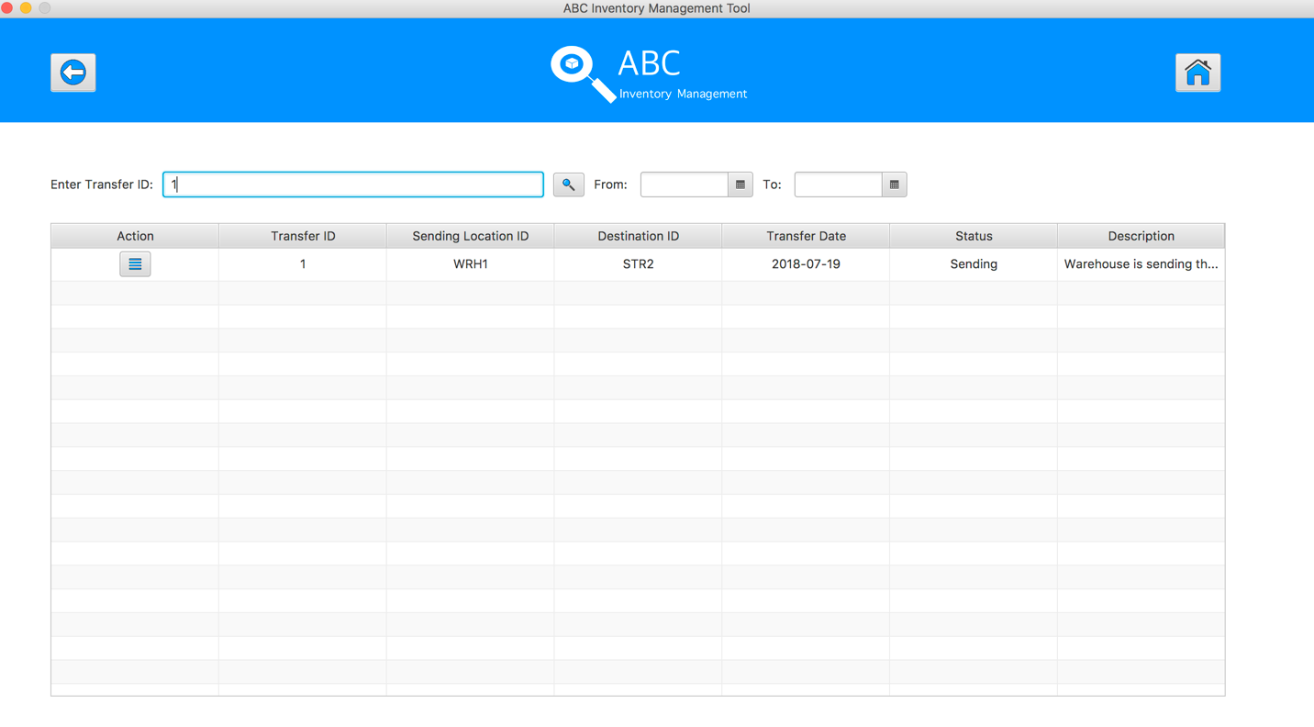

**Step 3**

Click on the “View Product in this Transfer” button, system display a list of product in selected transfer

